**Student Name: Shinde Smita Shahaji**

**UID: 20BCS4643**

**Date of Performance:05/13/2021**

**Branch: CSE-IOT Section/Group: IOT -B**

**Subject Name:Digital Electronics lab**

**AIM**

* Design an automatic heater controller using NOT gate such that at temperature below 10oC the heater should turn ON (the heater can be represented by using an LED).

**Task to be done**

The practical applications of logic gate {NOT}

**Design an automatic fan controller (NOT).**

**Requirements**

# Software-

Tinker cad

# Hardware-

|  |  |  |
| --- | --- | --- |
| Sr.no | Apparatus | Quantity |
| 1. | 7404 IC-NOT | 1 |
| 2. | LED | 1 |
| 3. | Breadboard | 1 |
| 4. | Resister | 1 |
| 5. | Power supply | 1 |
| 6. | Connecting wires | 16 |

**Circuit diagram/ Block diagram-**

**Simulation Results:**

**Design an automatic fan controller (NOT).**

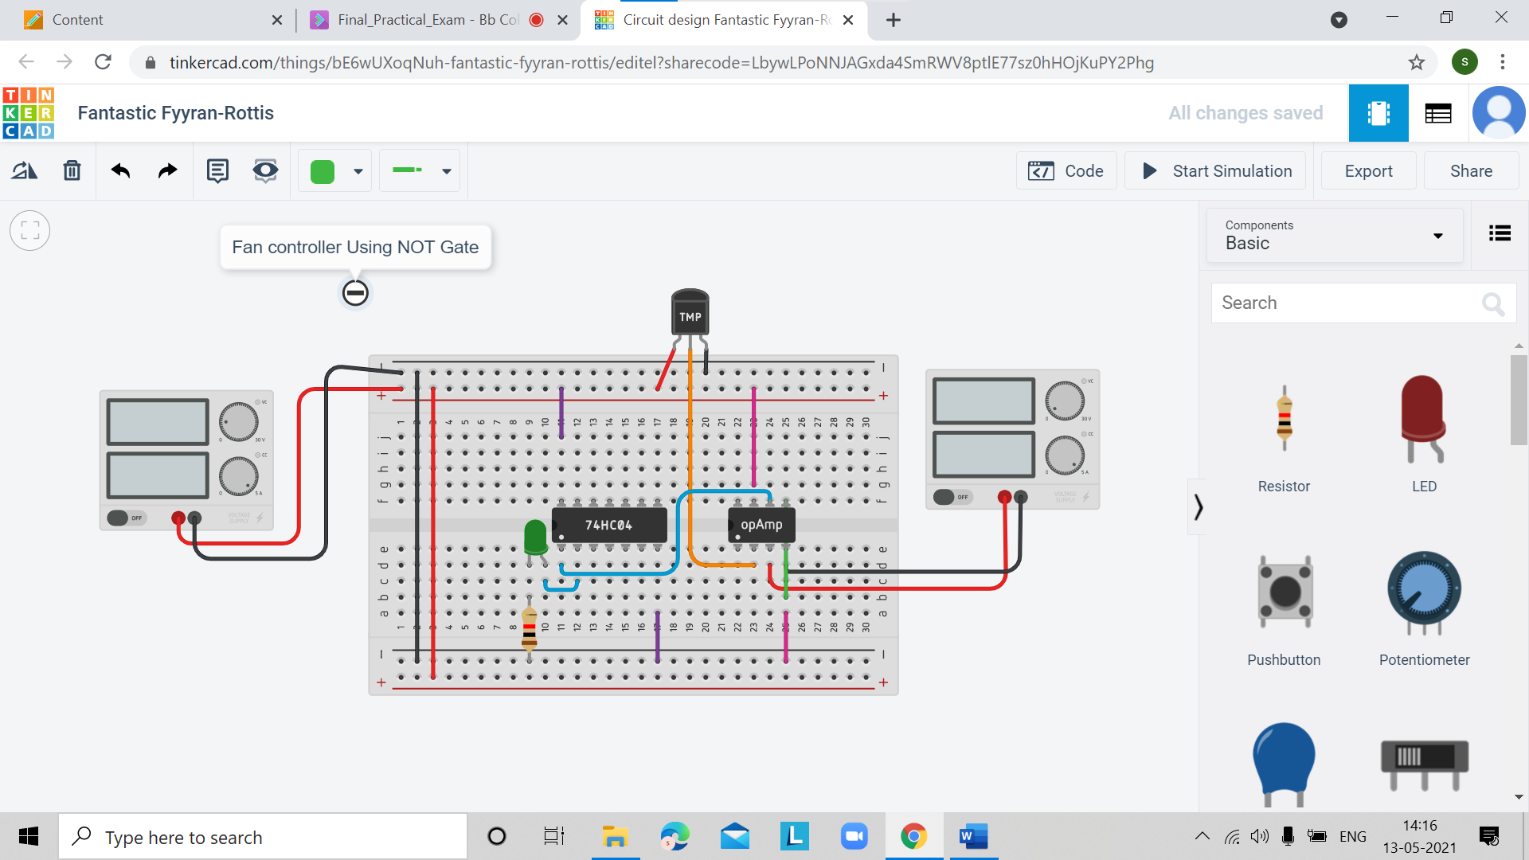

**Concept used.**

#### ****Design an automatic fan controller (NOT).****

1. **In automatic fan controller NOT gate was used having IC number [7404]**
2. **Firstly, fix temperature at constant like 30 degree Celsius.**
3. **When we need the warm during the winter, we want to room temperature became constant as 30 or more than that, we need to give more high inputs to warms up the room.**
4. **That time fixed central heating work on the conditions.**
5. **The temperature sensor input needs to be given to the input terminal of any one of the NOT gate inside this IC, and the output actuator can be driven from the output terminal of the same gate.**

**Troubleshooting**

1. On thinker cad the LM35 is not available instead of the LM35 we used in the circuit diagram as temperature sensor is TMP36.
2. Should be all connection will be connected.
3. Most careful about input and output connections.

#### Result-

The integrated circuits and their connections on the breadboard were studied and implemented. The practical applications of logic gate ( NOT) were studied and implemented.